1.data frames,covariance:

emp.date<-data.frame

age1=c("5-6","7-8","9-10")

a=c(12,34,45)

b=c(56,67,78)

c=c(89,90,12)

photo1=data.frame(age1,a,b,c)

photo1

s1=cov(a,b)

s1

photo1=data.frame(a,b,c)

photo1

s2=cov(photo1)

s2

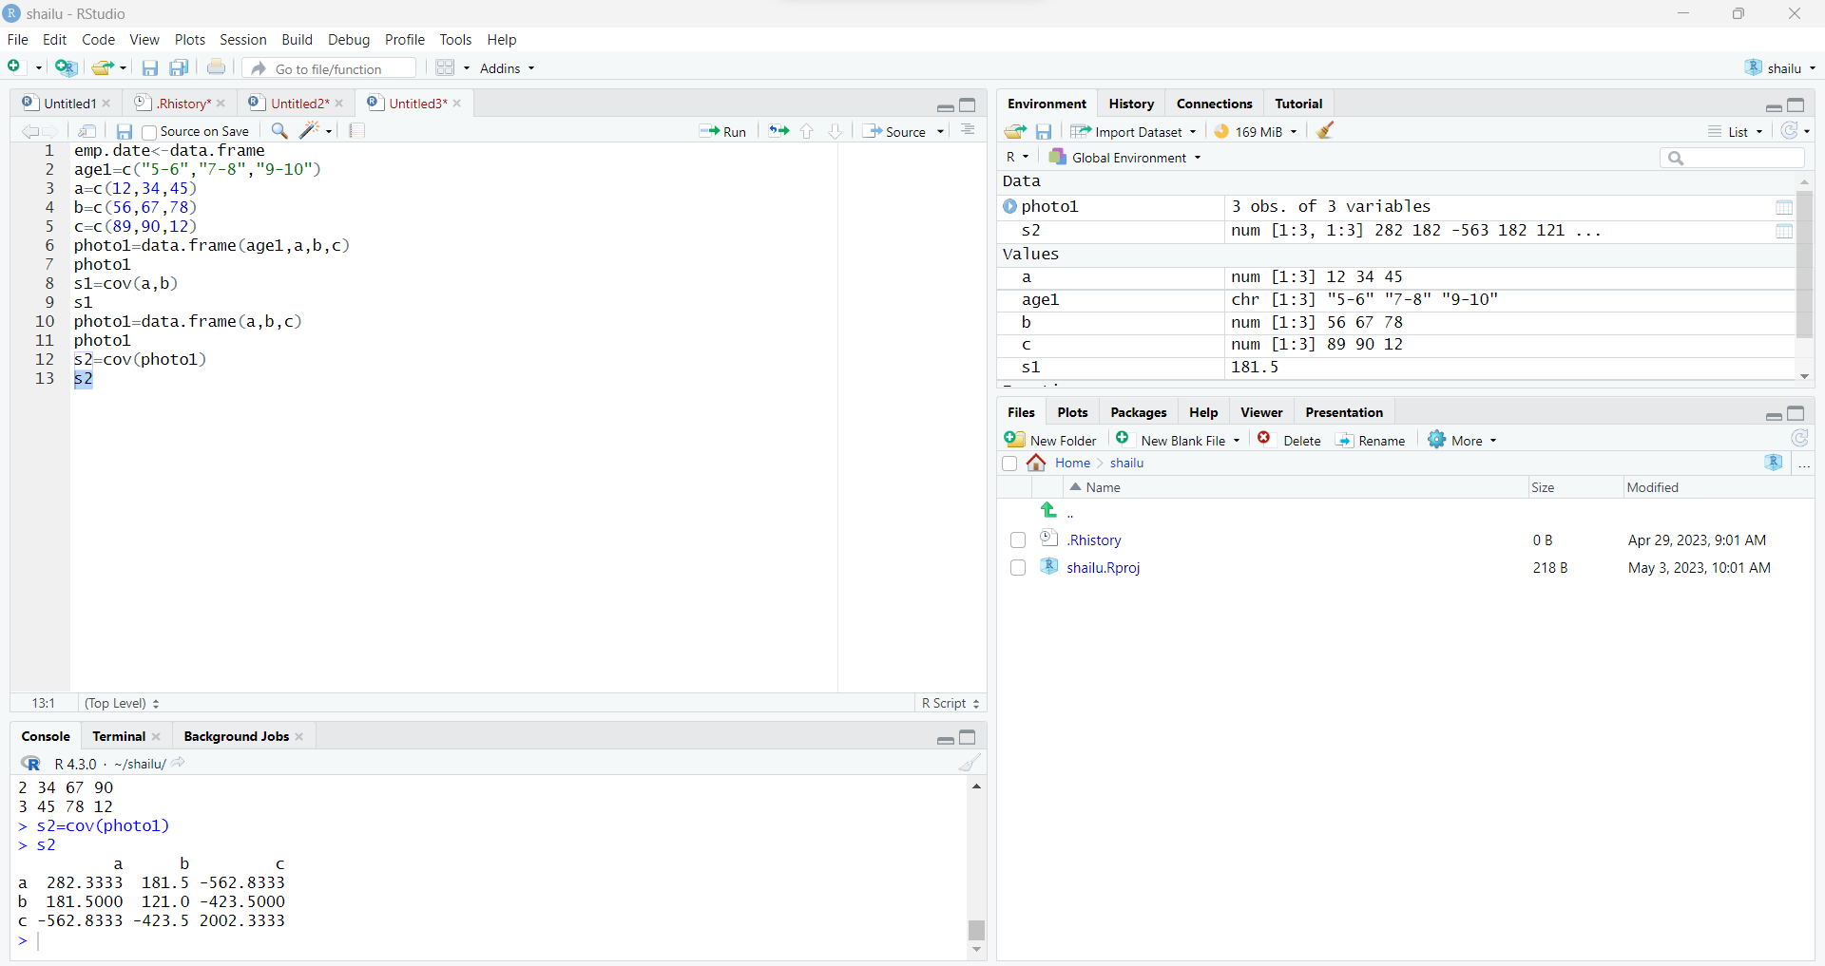

2. histogram graph:

c1=c(1,1,5,5,5,5,5,8,8,10,10,10,10,12,14,14,14,15,15,15,15,18,18,18,18,18,0,20,20,20,20,20,21,21,21,21,25,25,25,25,25,28,28,30)

hist(c1)

c2=c(1,1,5,5,5,5,5,8,8,10,10,10,10,12,14)

c3=c(14,14,15,15,15,15,18,18,18,18,18,0,20,20,20)

c4=c(20,20,21,21,21,21,25,25,25,25,25,28,28,30)

s1=mean(c2)

s1

s2=mean(c3)

s2

s3=mean(c4)

s3

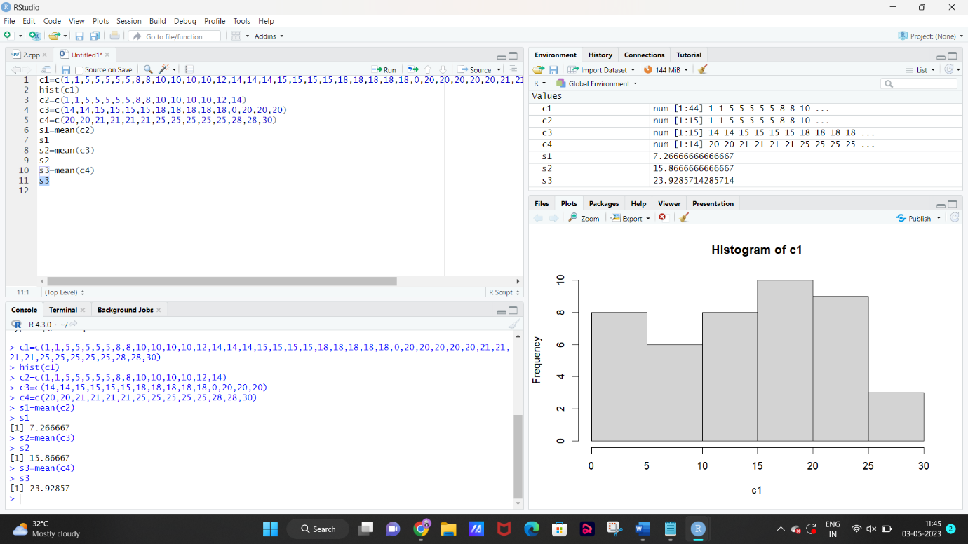

3.box plot:

c1=c(76,35,47,64,95,66,89,36,84,76,35,47,64,95,66,89,36,84)

c2=c(51,56,84,60,59,70,63,66,50,51,56,84,60,59,70,63,66,50)

s1=mean(c1)

s1

s2=mean(c2)

s2

s3=median(c1)

s3

s4=median(c2)

s4

s5=range(c1)

s6=range(c2)

s6

boxplot(c1~c2,xlab="x values",ylab="y values",main="sample")

head(ToothGrowth)

boxplot(c1~c2,xlab="class c1",ylab="class b",main="class 9 maths performance")

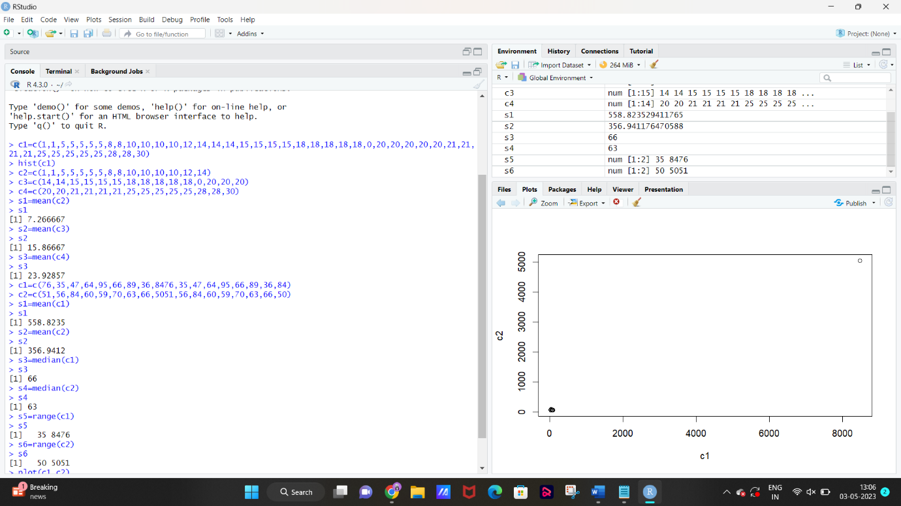

4.mean,median,sd:

age=c(23,23,27,27,39,41,47,49,50,52,54,54,56,57,58,58,60,61)

fact=c(9.5,26.5,7.8,17.8,31.4,25.9,27.4,27.2,31.2,34.6,42.5,28.8,33.4,30.2,34.1,32.9,41.2,35.7)

s1=mean(age)

s1

s2=mean(fact)

s2

s3=median(age)

s3

s4=median(fact)

s4

s5=sd(age)

s5

s6=sd(fact)

s6

boxplot(age~fact,xlab="fact values",ylab="age values",main="sample")

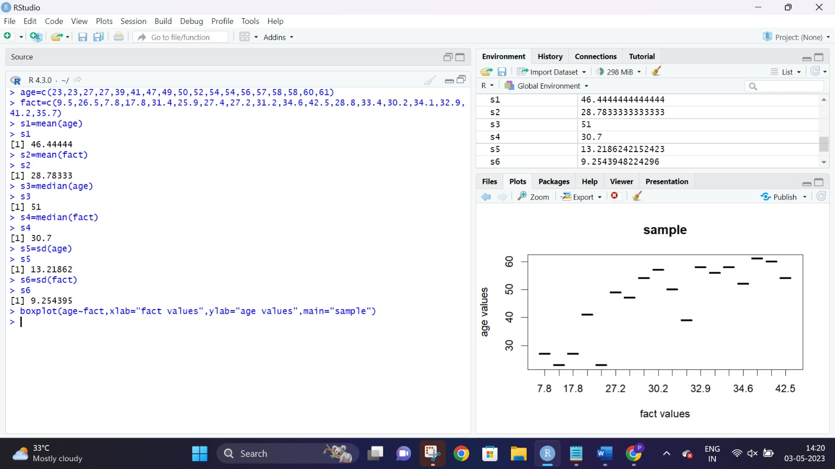

5.max min normalise:

age=c(23,23,27,27,39,41,47,49,50,52,54,54,56,57,58,58,60,61)

fact=c(9.5,26.5,7.8,17.8,31.4,25.9,27.4,27.2,31.2,34.6,42.5,28.8,33.4,30.2,34.1,32.9,41.2,35.7)

min_age<-min(age)

max_age<-max(age)

norm_age_minmax<-(39-min_age)/(max_age-min_age)

norm_age_minmax

mean_age=mean(age)

mean_age

sd_age=sd(age)

sd_age

norm_age_zscore<-(39-mean_age)/sd_age

norm_age_zscore

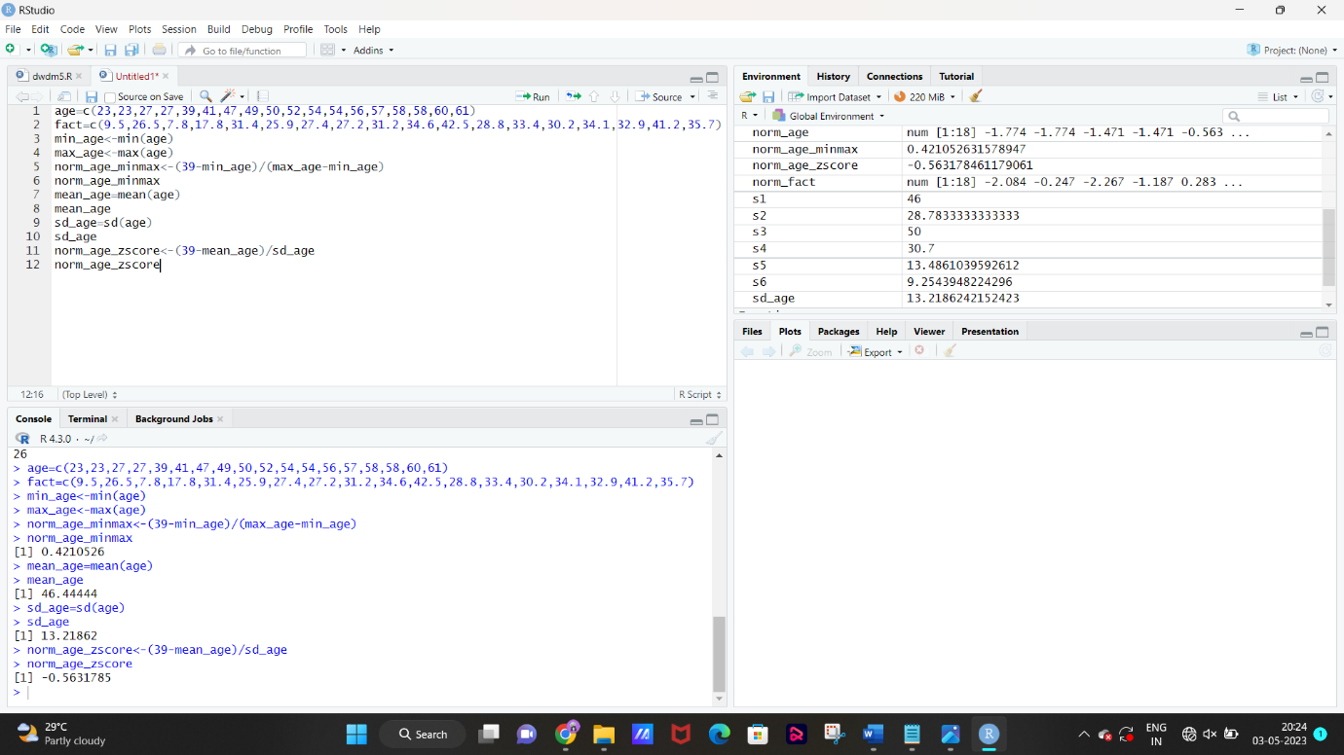

6.minmax,zscore,decimal scaling:

c1=c(200,300,400,600,1000)

max(c1,nm.rm=TRUE)

min(c1,nm.rm=TRUE)

z_score_norm<-function(x){(x-mean(x))/sd(x)}

norm_c1<-z_score_norm(c1)

cat("Normalised c1:",norm_c1,"\n")

max_abs_value<-max(abs(c1))

scale_factor<-10^(ceiling(log10(max_abs_value))+1)

scaled_c1<-c1/scale_factor

cat("original c1:",c1,"\n")

cat("scaled numbers:",scaled_c1,"\n")

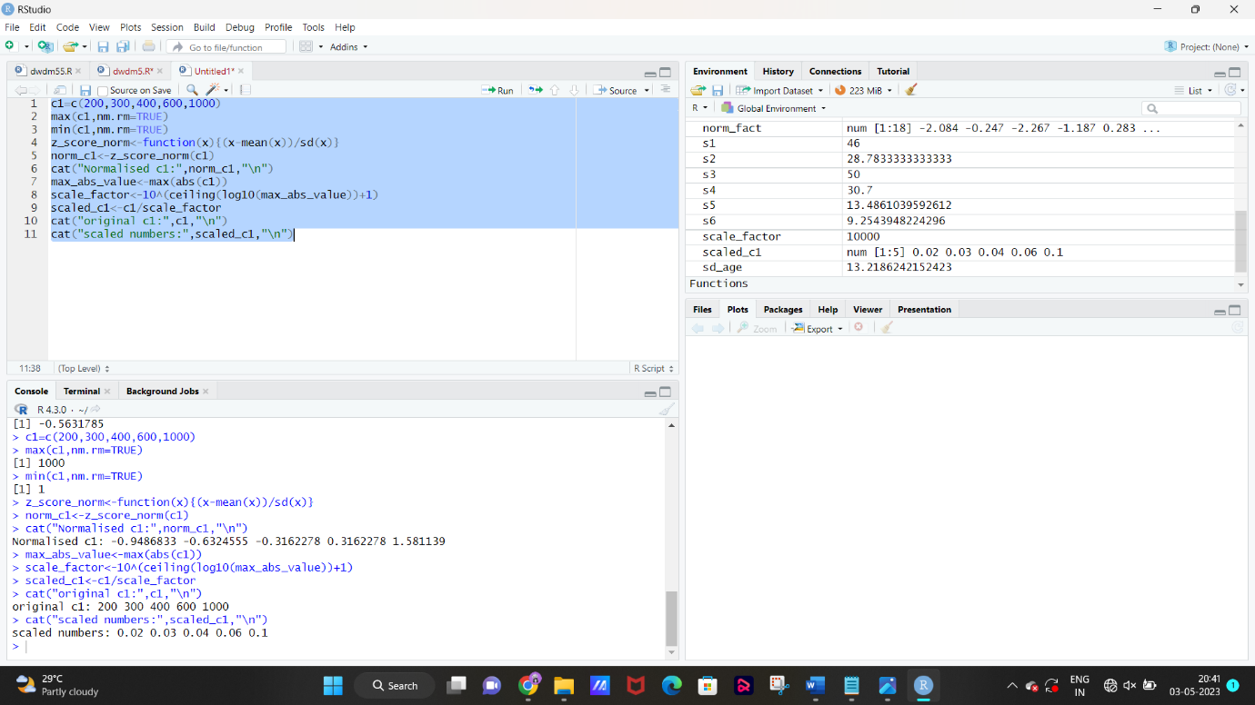

7.box ,scatter,plot:

class_a <- c(76,35,47,64,95,66,89,36,84)

class_b <- c(51,56,84,60,59,70,63,66,50)

boxplot(class_a, class_b, main = "Boxplot of Exam Scores", names = c("class A", "class B"), ylab = "Score")

plot(class_a, class_b, main = "Scatter plot of Exam Scores", xlab = "class A scores", ylab = "class B Scores")

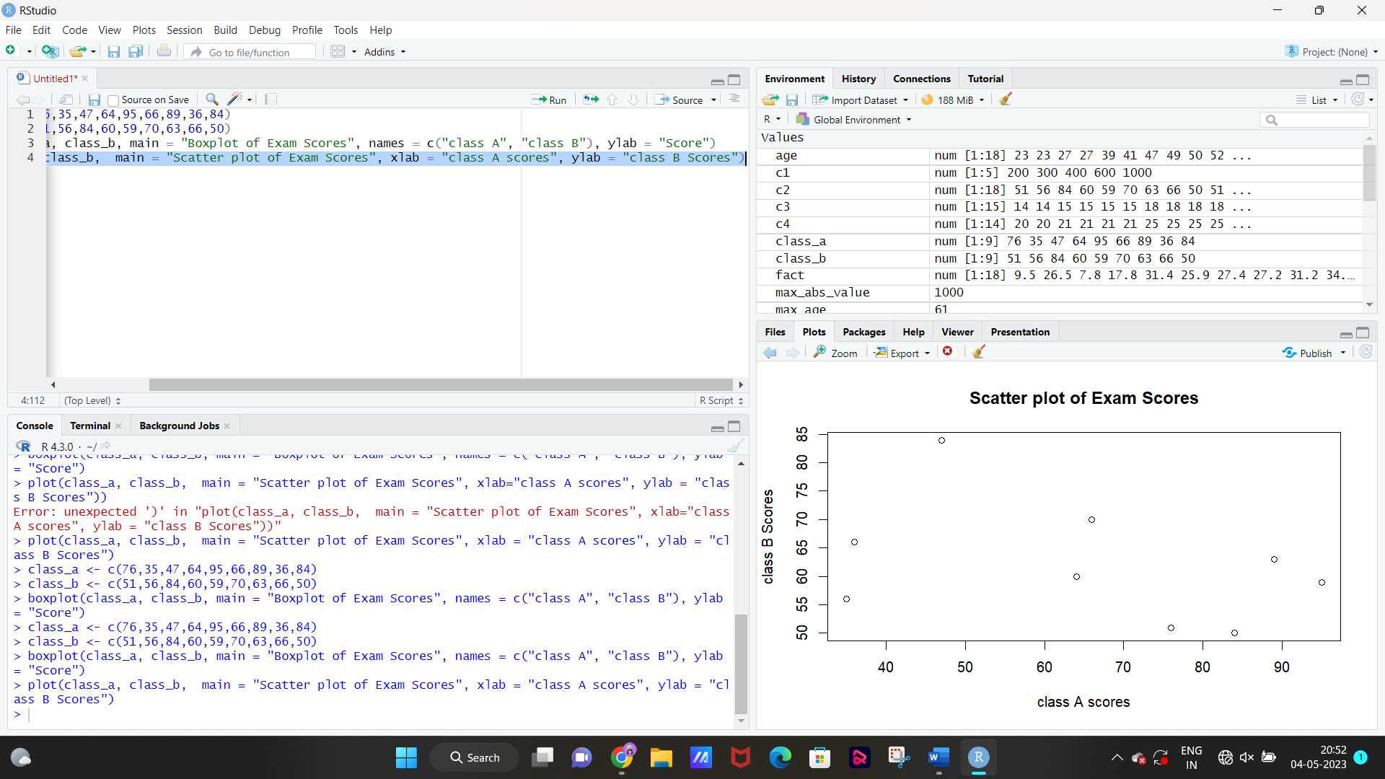

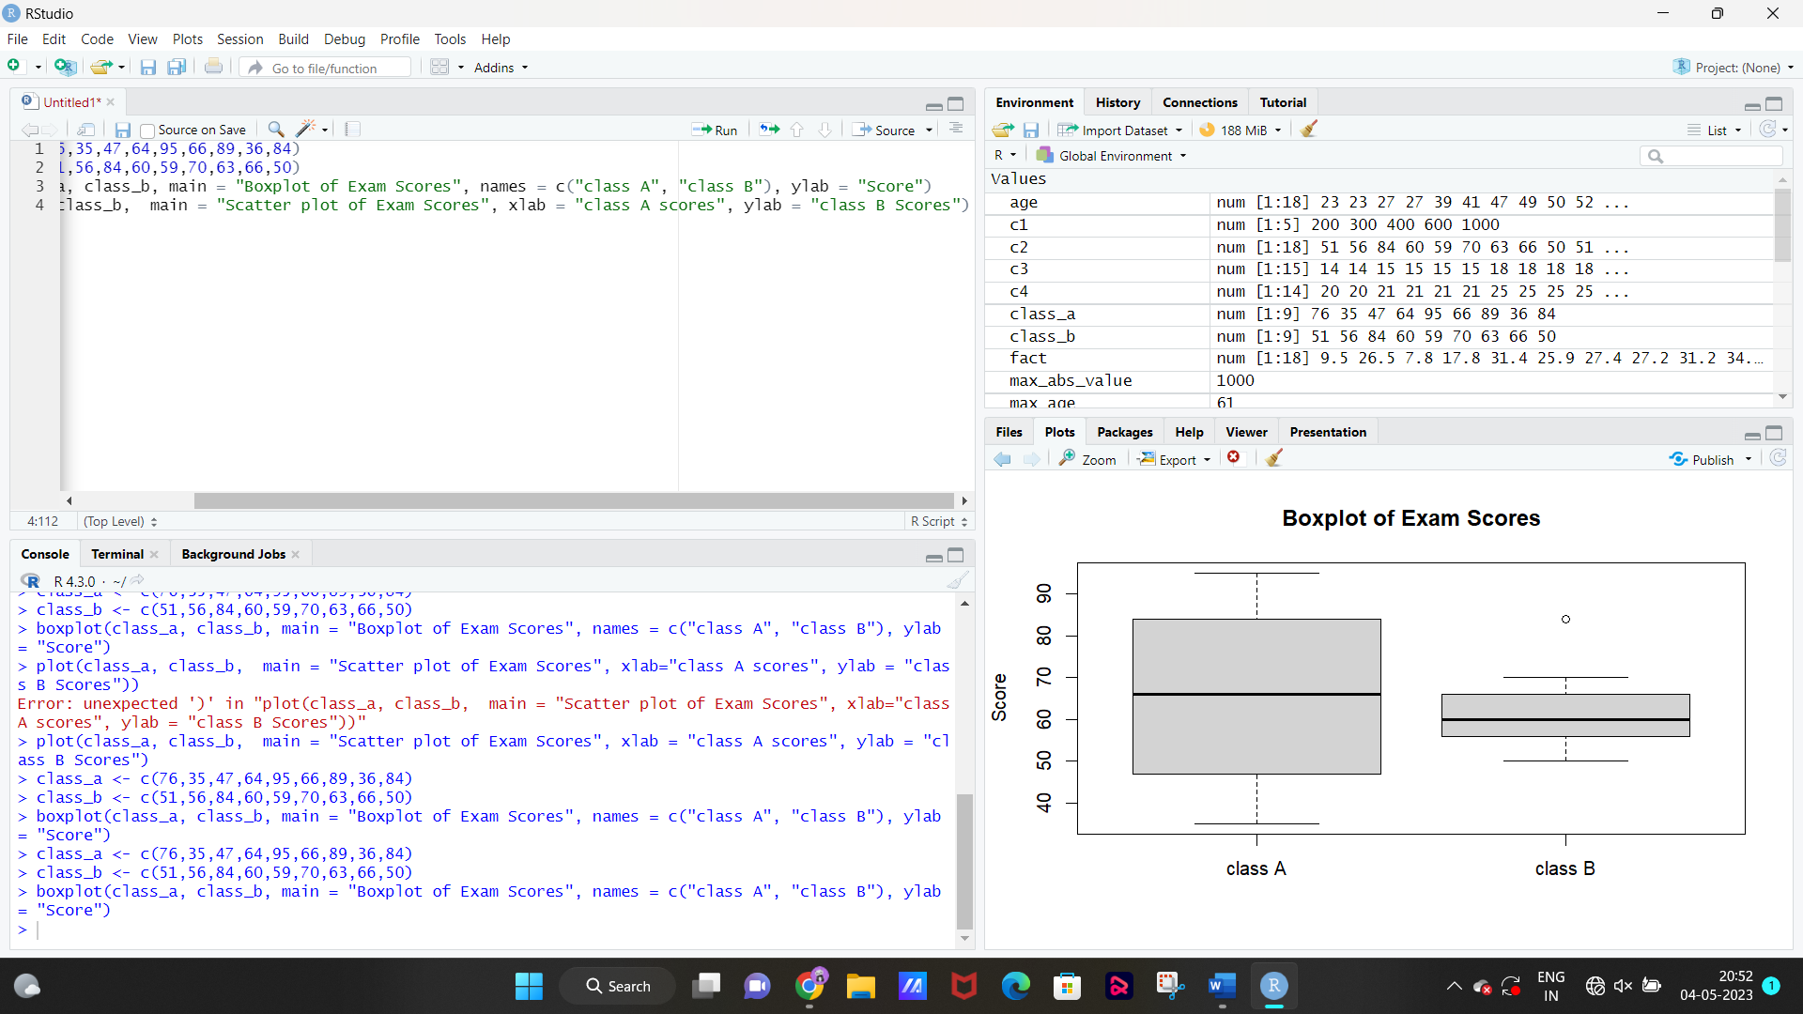

8.box ,scatter,qq plot

age=c(23,23,27,27,39,41,47,49,50,52,54,54,56,57,58,58,60,61)

fact=c(9.5,26.5,7.8,17.8,31.4,25.9,27.4,27.2,31.2,34.6,42.5,28.8,33.4,30.2,34.1,32.9,41.2,35.7)

boxplot(age,fact,names=c("AGE","FACT"),col="red",main="AGE and FACT data")

plot(age, fact, main="AGE and FACT data", xlab="AGE", ylab="FACT", col="green")

qqnorm(age)

qqline(age,col="red")

qqnorm(fact)

qqline(fact,col="red")

